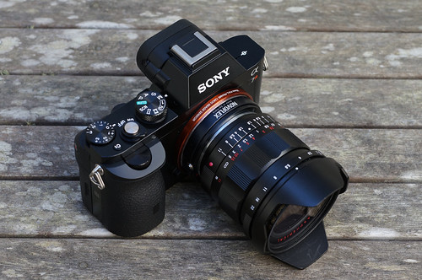

Sony Alpha 7R V Full-Frame Mirrorless Camera
The Sony Alpha 7R V (A7R V) is a flagship-level full-frame mirrorless camera designed for professional photographers, filmmakers, and content creators who require ultra-high image resolution, cutting-edge autofocus, and exceptional video performance. Equipped with Sony’s latest imaging technology, the A7R V delivers outstanding image quality, remarkable speed, and advanced AI-powered features, making it an excellent choice for landscape, portrait, fashion, wildlife, commercial, architectural, and studio photography.
At the heart of the Sony A7R V is a 61.0-megapixel Full-Frame Exmor R Back-Illuminated (BSI) CMOS sensor, capable of capturing stunningly detailed images with exceptional sharpness, vibrant colors, and a wide dynamic range. The camera is powered by the BIONZ XR Image Processor, which provides up to eight times faster processing than previous generations, resulting in improved image quality, faster autofocus, and enhanced overall performance.
One of the camera's most advanced features is its AI Processing Unit, which significantly improves autofocus accuracy and subject recognition. The camera can intelligently detect and track humans, animals, birds, insects, cars, trains, and airplanes. Real-Time Eye Autofocus ensures precise focus on the subject's eyes, even when they are moving or partially obscured.
The Sony A7R V features an advanced 5-axis In-Body Image Stabilization (IBIS) system offering up to 8 stops of stabilization. This allows photographers to capture sharp handheld images in low-light conditions and enables videographers to record smooth, stable footage without external stabilization equipment.
For professional video production, the A7R V supports 8K video recording at 24/25fps and 4K recording up to 60fps with 10-bit 4:2:2 internal recording. It also supports S-Log3, S-Cinetone, HLG, and XAVC HS/XAVC S recording formats, providing outstanding flexibility for cinematic productions, documentaries, YouTube content, and commercial filmmaking.
The camera features a 9.44-million-dot OLED Electronic Viewfinder (EVF)—one of the highest-resolution EVFs available—providing a bright, detailed, and highly accurate view of the scene. The 3.2-inch 4-axis multi-angle touchscreen LCD offers maximum flexibility for photography, videography, and creative shooting angles.
Designed for professional workflows, the Sony A7R V includes dual memory card slots compatible with both CFexpress Type A and UHS-II SD cards, enabling fast data transfer, reliable backup, and uninterrupted shooting. Built-in Wi-Fi, Bluetooth, USB-C, HDMI, microphone input, and headphone output provide seamless connectivity for professional multimedia production.
Constructed from a weather-sealed magnesium alloy body, the Sony A7R V is resistant to dust and moisture, ensuring dependable performance in challenging outdoor environments.

Key Features
- Camera Type: Full-Frame Mirrorless Camera
- Sensor: 61.0 MP Full-Frame Exmor R BSI CMOS Sensor
- Image Processor: BIONZ XR
- AI Processor: Dedicated AI Processing Unit
- Lens Mount: Sony FE (E-Mount)
- Autofocus: AI Real-Time Tracking with Eye AF
- Image Stabilization: 5-Axis IBIS (Up to 8 Stops)
- Continuous Shooting: Up to 10 fps
- Video Recording: 8K (24/25fps), 4K UHD (Up to 60fps)
- Video Format: 10-bit 4:2:2 Internal Recording
- Color Profiles: S-Log3, S-Cinetone, HLG
- Electronic Viewfinder: 9.44M-dot OLED EVF
- LCD Screen: 3.2-inch 4-Axis Multi-Angle Touchscreen
- Memory Card Slots: Dual CFexpress Type A / UHS-II SD
- Connectivity: Wi-Fi, Bluetooth, USB-C, HDMI
- Audio Ports: 3.5 mm Microphone Input & Headphone Output
- Battery: Sony NP-FZ100 Rechargeable Battery
- Body Construction: Weather-Sealed Magnesium Alloy
- Weight: Approximately 723 g (with battery and memory card)

Advantages
- Ultra-high 61 MP image resolution for maximum detail
- Advanced AI-powered autofocus and subject recognition
- Excellent low-light performance and dynamic range
- Powerful 8-stop in-body image stabilization
- Professional 8K and 4K video recording
- High-resolution 9.44M-dot electronic viewfinder
- Dual CFexpress Type A and SD card slots
- Durable weather-resistant magnesium alloy body
- Wireless connectivity for quick file transfer and remote shooting
- Ideal for both professional photography and filmmaking

Applications
The Sony Alpha 7R V is ideal for:
- Professional Photography
- Landscape Photography
- Portrait Photography
- Wildlife Photography
- Sports Photography
- Wedding Photography
- Fashion Photography
- Commercial Photography
- Product Photography
- Architectural Photography
- Studio Photography
- Documentary Filmmaking
- YouTube Content Creation
- Corporate Video Production
- Live Streaming
- Cinematic Video Production

